Module Assembly - NASA SMG NodeJS API version Deployment Guide

Revision History
Author | Revision Number | Date
TCSASSEMBLER | 1.0 | 09.03.2014
TCSASSEMBLER | 1.1 | 27.04.2014

Deployment Instructions 3
1. Organization of Submission 3
2. Application Technologies 3
3. Application Setup 3
4. Configurations 4
4.1. Database setup 4
5. Deployment Instructions 5
6. Verification 6
7. Resource Contact List 10

Deployment Instructions

Organization of Submission

nasa-smg | Main application directory
nasa-smg\config | Contains configuration files.
nasa-smg\controllers | Contains controllers
nasa-smg\downloads | Contains upload files.
nasa-smg\errors | Contains definition for error objected used in application.
nasa-smg\helpers | Contains helpers and utilities.
nasa-smg\models | Contains models
nasa-smg\sql | Contains sql files, which create the foreign key or unique constraints
nasa-smg\.env_sample | The sample environment configuration
nasa-smg\.gitignore | Represents ignored files for git
nasa-smg\app.js | Main application entry.
nasa-smg\config.js | Configures express app.
nasa-smg\db.js | Load db and initialize models
nasa-smg\generateData.js | Script for generating sample data.
nasa-smg\package.json | Module dependencies for application.
nasa-smg\postman.json | Contains definition for API routes for postman chrome extension.
web.config | The definitions to be used when running the application inside IIS
Module Assembly - NASA SMG NodeJS API version 1.0 - IIS.doc | This file.

Application Technologies
- IIS
- IISnode https://github.com/tjanczuk/iisnode
- Node.js http://nodejs.org/
- Postman
- MySQL

Application Setup

We assume that IIS is already available on your server. If that is not the case, then follow the instructions at: http://www.iis.net/learn/get-started/whats-new-in-iis-8/installing-iis-8-on-windows-server-2012
Install latest version of iisnode from https://github.com/tjanczuk/iisnode. Follow their instructions to install node (Read the sections called “Prerequisites for using” and “Installing for IIS*”
Install MySQL from http://dev.mysql.com/downloads/
Install postman extension to chrome browser from here https://chrome.google.com/webstore/detail/postman-rest-client/fdmmgilgnpjigdojojpjoooidkmcomcm/related?hl=en

Configurations
Configuration is done at the web.config file. If you open it, there will be a section called “appSettings”. In that section you can find the following options:

Name | Description | Default value
DB_HOST | The host for MySQL server. | localhost
DB_NAME | The MySQL database name. | nasa-smg
DB_PORT | The port for MySQL server. | 3306
DB_USER | The username to login to MySQL. | root
DB_PASSWORD | The password to mysql server. | <empty>
RESET_TABLES | The flag if recreate database. It will drop and create again all tables. Test data is not inserted. Tables will be reset each time you run node app. | false
DOWNLOADS_DIR | The path to directory where files are downloaded. If not set then files are downloaded to nasa-smg/downloads. | <empty>
PORT | The port which application listen to. | 3000

Change the values on that configuration before running the server. If you change them after it is better to restart IIS from the IIS manager.

Database setup
You must create only empty database in mysql server. Default database name is nasa-smg. Application will create all required tables.

Deployment Instructions

IIS configuration
- Run npm install in directory <submission>/nasa-smg
- Setup configuration web.config file if needed. See section 4.
- We have to be able to override configuration sections and to use URL authorization. Therefore we need to be sure that they are installed on IIS.
  - For windows server 2012
    - Click "Start button"
    - In the search box, enter "Turn windows features on or off". Click on settings under the search box if nothing is displayed.
    - In the features window, Click: "Internet Information Services"
    - Click: "World Wide Web Services"
    - Click: "Application Development Features"
    - Check (enable) the features. You can check all, or leave out CGI.
    - Click: "Security"
    - Check (enable) the URL Authorization feature.
    - Click "Next" until finish.
  - For windows server 2008
    - Go to the control panel
    - In the search box, enter "Turn windows features on or off".
    - The server manager will open.
    - Go to the roles section
    - Go to the Web Server (IIS) section
    - Look for the Role Services subsection
    - Click: "Application Development Features"
    - Install all the services (you can leave out CGI).
    - Click: "Security"
    - Install the URL Authorization feature.
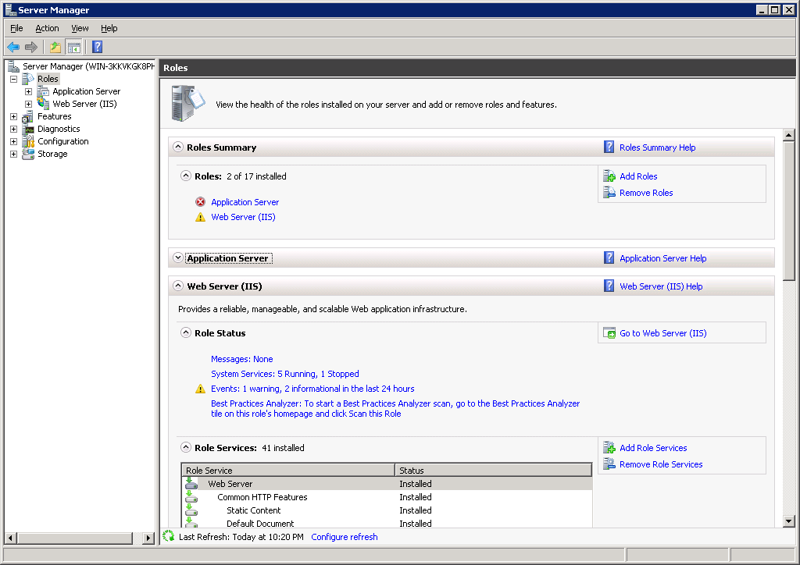

- Now we have to enable the override of the configuration sections.
  - Open the applicationHost.config file, located here: %windir%\system32\inetsrv\config\applicationHost.config
  - Edit the "handlers" section.
  - Change this line:
<section name="handlers" overrideModeDefault="Deny" />
To:
<section name="handlers" overrideModeDefault="Allow" />
  - Edit the "authentication" section group
  - Change this line:
<section name="anonymousAuthentication" overrideModeDefault="Deny" />
To:
<section name="anonymousAuthentication" overrideModeDefault="Allow" />
  - Change this line:
<section name="windowsAuthentication" overrideModeDefault="Deny" />
To:
<section name="windowsAuthentication" overrideModeDefault="Allow" />
  - Save the file
  - Restart IIS from the IIS manager
- Finally, we need to install the SMG application on IIS.
  - Open the IIS Manager
  - Go to “Default Web Site”
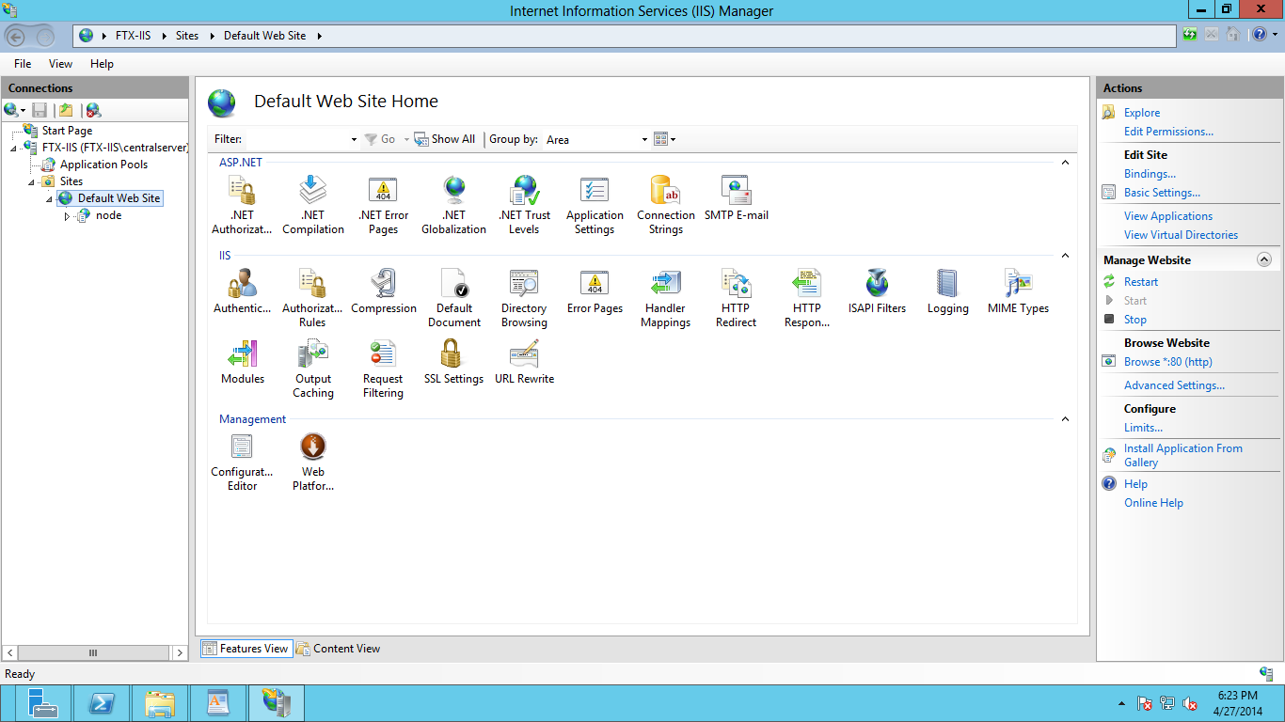
  - Right click to display the menu options. Select “Add application…”
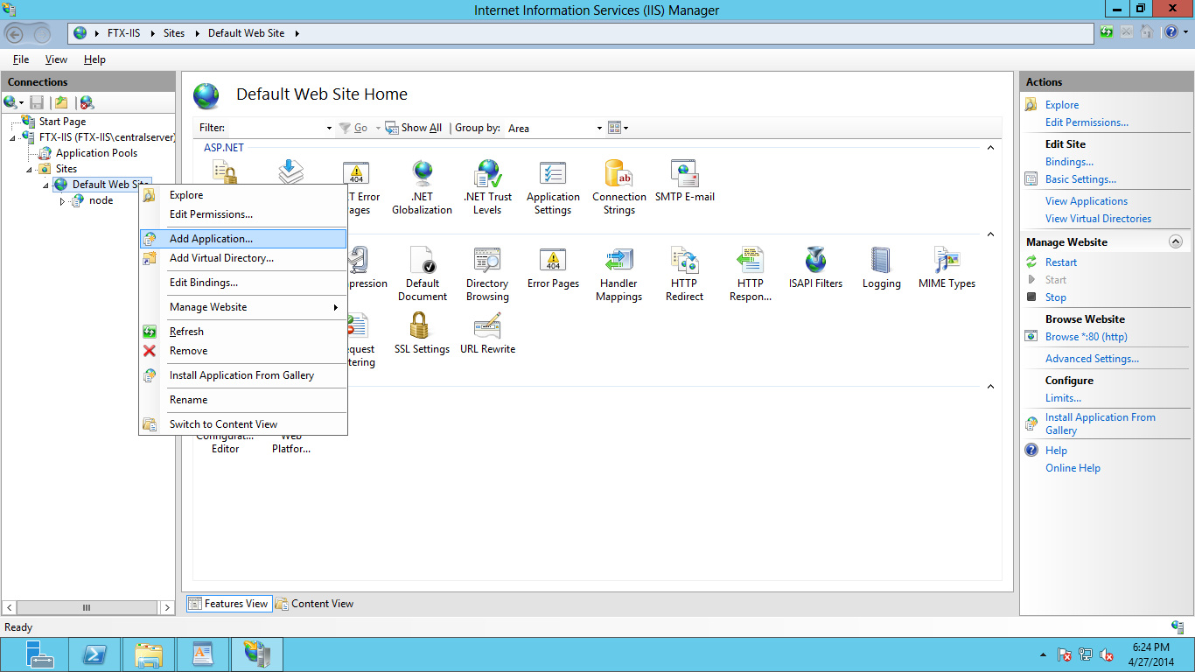
  - A popup will appear with all the configuration for a new application. Use smg as alias, and select the physical path where you have the solution.
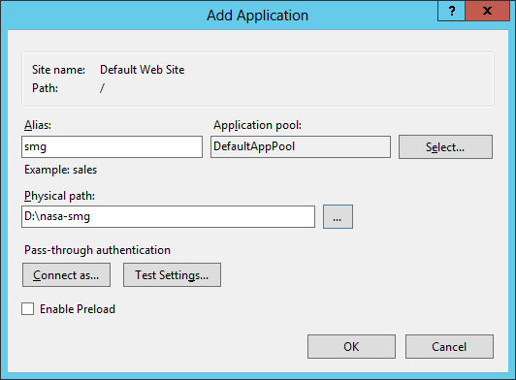
  - Done! You can check now http://localhost/smg/characteristicTypes (or any other GET endpoint) to test the application.
  - NOTE: from the IIS manager now you can change the application settings (to change DB settings for example), Authorization URL, Authentication types, etc.

Postman
Setup postman.json file. NOTE: Due to a bug in packaged postman when using NTLM authentication, you have to use a previous version of POSTMAN that does not run as a packaged application but inside the browser.
  - Open chrome-extension://fdmmgilgnpjigdojojpjoooidkmcomcm/index.html
  - Click import collection
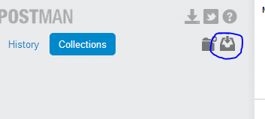
  - Choose file postman.json and close dialog.
  - Collection is imported now.
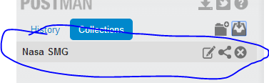
  - Go to environments settings.
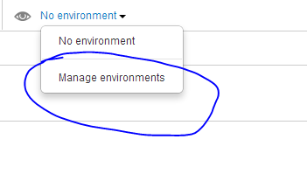
  - Set global value URL to http://localhost/smg. Change port if you are using different one on IIS. Change ‘smg’ if you select a different application name on IIS.
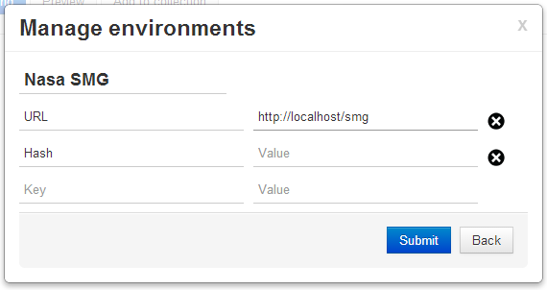
  - Now you can test API methods.

Verification

First short description about my solution.

I have implemented CharacteristicValueType as described in this post http://apps.topcoder.com/forums/?module=Thread&threadID=812457&start=45&mc=62#1853258

SMGCharacterstic have fields: value and valuetype_id. Both are optional.

SearchFormFieldValue have fields: value and valuetype_id. Both are optional also (they can be null on same time, I didn’t limit that).
If SearchFormFieldValue#value is not null then it will matched to the SMGCharacterstic#value
If SearchFormFieldValue#valuetype is not null then it will matched to the SMGCharacterstic#valuetype

Cascade delete is allowed only if SMGCharacterstic is not affected. That means if SMGCharacterstic is referencing entityX then entityX can’t be deleted. Except the case when we want to remove SMG entity, then all references values will be cascade deleted (it makes sense in Work Flow).
CharacteristicType can’t be deleted if is referenced by Characteristic.
CharacteristicTypeValue is cascade deleted if we delete the CharacteristicType
SearchFormField and SearchFormFieldValue are cascade deleted if we delete the Characteristic
Example#smg_is is set to null if we delete the SMG.

There is also update validation. For example
SMGCharacterstic has reference to Characterstic and CharactersticTypeValue. CharactersticTypeValue must be children of Characterstic#.type_id (CharactersticType). In this case we can’t update CharactersticTypeValue.type_id in CharactersticTypeValue API, because it will make SMGCharacterstic record invalid.

Test data (refer to genedateData.js)
SMG 1:
Summary: 'ok' (textbox value)
Deliverable Type: Knowledge (dropdown value – enum)
Tags: Red, White (2 values, selected 2 checkboxes)

SMG 2:
Summary: 'bad'
Deliverable Type: Technology
Tags: Black

SMG 3:
Summary: 'unknown'
Deliverable Type: Technology
Tags: Black, Yellow

Predefined Search forms (See endpoints Search#1 – Search#6)
- Summary must be ‘OK’
- Deliverable Type must be Technology
- Tags must be Black
- Tags must be Black or White
- Tags must be Red and White
- Tags must be Yellow AND Deliverable Type must be Technology (2 field)

There are many endpoints in postman and they are pretty straightforward.
Few notes:
- In batch methods, first all values are validated. If any value is invalid then error is returned. Valid values are not updated in this case.
- Update methods don’t need to define all properties. If some property is not set then it won’t be updated.
- Search methods support all field (except id field)
- Delete methods return deleted entities.
- CharTypeValue means CharacteristicTypeValue

Sample calls
Get ALL SMG (SMG – view all)
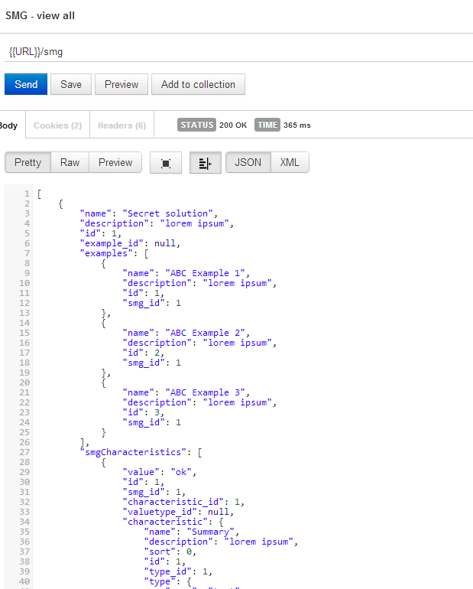

Get all examples by smg 1 (Example – search)
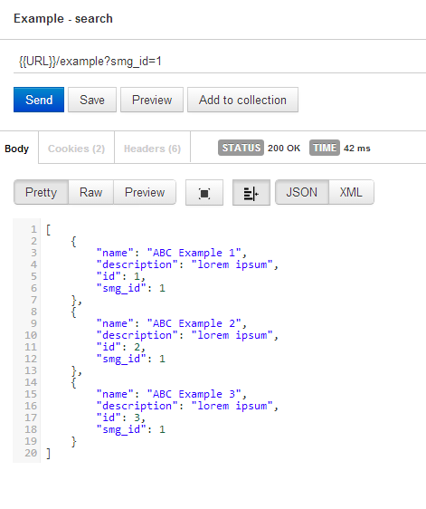

Search by active filter (Search by active), it’s same as Search#1.
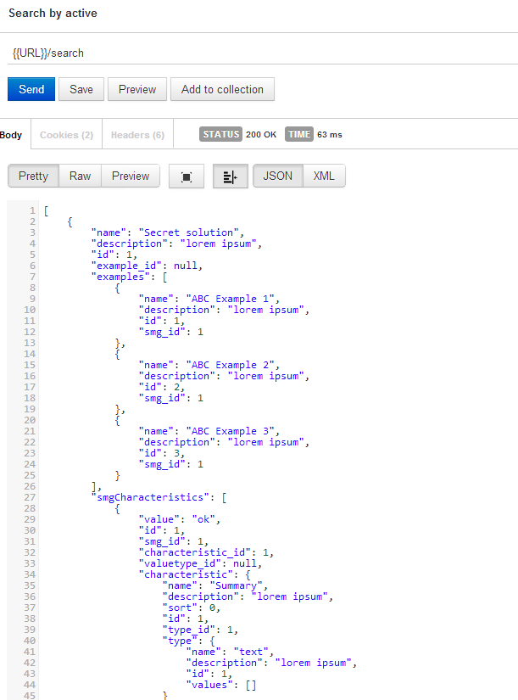

Delete ALL SMGs (SMG - delete batch)
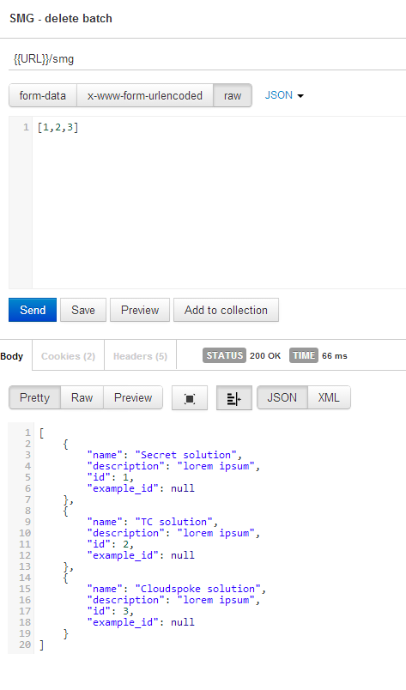

Get all SMGCharacteristic (SMGCharacteristic - view all)
It should return empty list, because we removed all SMGs in previous steps
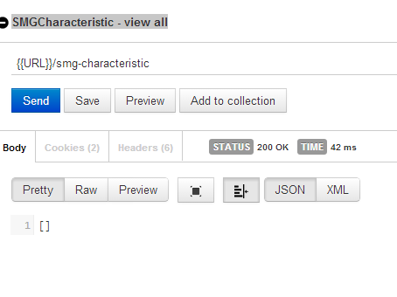

Create HelperTopic (HelperTopic – create)
It allows to upload any file.

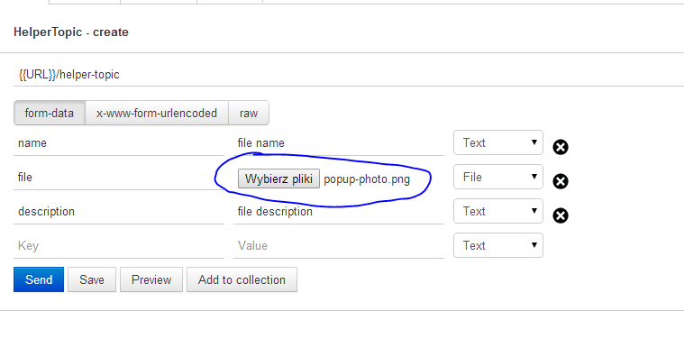
Choose a file (This text means ‘Choose a file’)

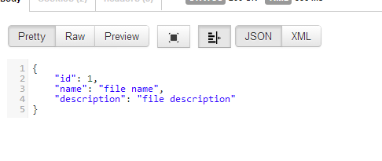
File can be downloaded in different API.
HelperTopic – download
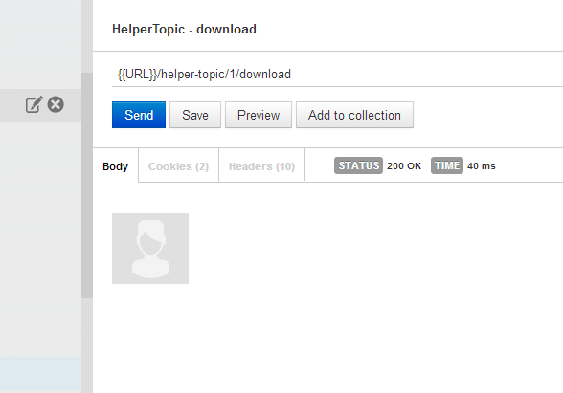
If mime type is set correctly then Postman render it

Resource Contact List

Name | Resource Email

